**DIFFERENCE BETWEEN DOCUMENT AND WINDOW OBJECT**

There seem to be a lot of misconceptions about the difference between document and window objects for JavaScript.

***The WINDOW object and DOCUMENT object ARE NOT THE SAME!!!***

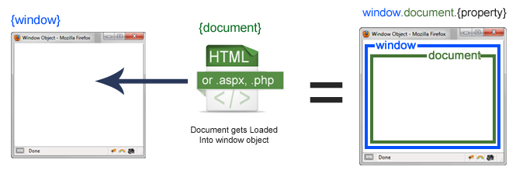

**Window Object**

The **window object** represents a window in the browser. An object of the window is created automatically by the browser.

The window is the object of the browser, **it is not the object of JavaScript**. The JavaScript objects are string, array, date, etc. Each browser tab has its own top-level window object. Each <iframe> (and deprecated <frame>) element has its own window object too, nested within a parent window. Each of these windows gets its own separate global object. window always refers to the window, but a window. parent and window. top might refer to enclosing windows, giving access to other execution contexts. In addition to the document and screen described below, window properties include

* setTimeout() and setInterval() binding event handlers to a timer
* location giving the current URL
* history with methods back() and forward() giving the tab's mutable history
* navigator describing the browser software

A web browser is made up of a hierarchy of objects. At the root level, we have a window object. It is the root-level element in any web page.

* All the global variables are defined on the window object.
  + For example, alert(), confirm() are methods defined on the window object.
  + Writing alert() is similar to a window.alert()
  + Also, properties like document and location are properties of the window object.
  + [window API](https://developer.mozilla.org/en-US/docs/Web/API/Window)

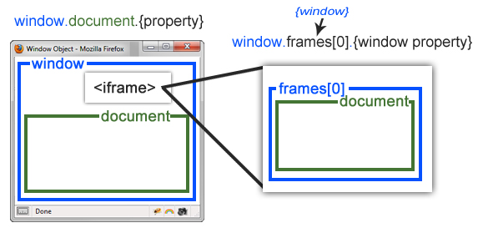

The property to access a frame is a window. frames[], which is an array of all the frames. If you only have one iframe you access it by using a window. frames[0]. Since the iframe is also a window object, accessing the window properties of that frame is done by using a window. frames[0].mywindowproperty.

**PROPERTY OF WINDOW OBJECT**

| **Property** | **Description** |
| --- | --- |
| closed | Returns a Boolean value indicating whether a window has been closed or not |
| defaultStatus | Sets or returns the default text in the statusbar of a window |
| document | Returns the Document object for the window |
| frameElement | Returns the, **<iframe>** element in which the current window is inserted |
| frames | Returns all,**<iframe>**elements in the current window |
| history | Returns the History object for the window |
| innerHeight | Returns the inner height of a window's content area |
| innerWidth | Returns the inner width of a window's content area |
| length | Returns the number of, **<iframe>** elements in the current window |
| location | Returns the Location object for the window (See Location object) |
| name | Sets or returns the name of a window |
| navigator | Returns the Navigator object for the window (See Navigator object) |
| opener | Returns a reference to the window that created the window |
| outerHeight | Returns the outer height of a window, including toolbars/scrollbars |
| outerWidth | Returns the outer width of a window, including toolbars/scrollbars |
| pageXOffset | Returns the pixels the current document has been scrolled (horizontally) from the upper left corner of the window |
| pageYOffset | Returns the pixels the current document has been scrolled (vertically) from the upper left corner of the window |
| parent | Returns the parent window of the current window |
| screen | Returns the Screen object for the window (See Screen object) |
| screenLeft | Returns the horizontal coordinate of the window relative to the screen |
| screenTop | Returns the vertical coordinate of the window relative to the screen |
| screenX | Returns the horizontal coordinate of the window relative to the screen |
| screenY | Returns the vertical coordinate of the window relative to the screen |
| self | Returns the current window |
| status | Sets or returns the text in the status bar of a window |
| top | Returns the topmost browser window |

**Document Object**

* It is the direct child of the window object. It is aka Document Object Model (DOM).
* You can access it via the window. document or document.
* document object has many useful methods defined on it.
* For example, document.getElementById(), document.getElementByTagName(), document.createElement(), document.querySelector() and many more
* [document API](https://developer.mozilla.org/en-US/docs/Web/API/Document)

The document object is your HTML, aspx, PHP, or another document that will be loaded into the browser. The document actually gets loaded inside the window object and has properties available to it like title, URL, cookie, etc. What does this really mean? That means if you want to access a property for the window it is a window. property, if it is a document it is window.document.property which is also available in short as a document. property.

Each window object has a document object to be rendered. These objects get confused in part because HTML elements are added to the global object when assigned a unique id. E.g., in the HTML snippet

***<body>***

***<p id="holyCow"> This is the first paragraph.</p>***

***</body>***

the paragraph element can be referenced by any of the following:

* window.holyCow or window["holyCow"]
* document.getElementById("holyCow")
* document.querySelector("#holyCow")
* document.body.firstChild
* document.body.children[0]

**Properties and Methods of Document Object:**

| **Property / Method** | **Description** |
| --- | --- |
| document. body | Sets or returns the document's body (the element) |
| document.close() | Closes the output stream previously opened with a document.open() |
| document. cookie | Returns all name/value pairs of cookies in the document |
| document. create attribute() | Creates an attribute node |
| document.createComment() | Creates a Comment node with the specified text |
| document.createDocumentFragment() | Creates an empty DocumentFragment node |
| document.createElement() | Creates an Element node |
| document.createTextNode() | Creates a Text node |
| document.doctype | Returns the Document Type Declaration associated with the document |
| document.documentElement | Returns the Document Element of the document (the element) |
| document.documentMode | Returns the mode used by the browser to render the document |
| document.document URI | Sets or returns the location of the document |
| document. domain | Returns the domain name of the server that loaded the document |
| document.domConfig | Obsolete. Returns the DOM configuration of the document |
| document. embeds | Returns a collection of all, elements of the document |
| document. forms | Returns a collection of all, elements in the document |
| document.getElementById() | Returns the element that has the ID attribute with the specified value |
| document.getElementsByClassName() | Returns a NodeList containing all elements with the specified class name |
| document.getElementsByName() | Returns a NodeList containing all elements with a specified name |
| document.getElementsByTagName() | Returns a NodeList containing all elements with the specified tag name |
| document.hasFocus() | Returns a Boolean value indicating whether the document has a focus |
| document.head | Returns the,element of the document |
| document. images | Returns a collection of all, **<img>** elements in the document |
| document.importNode() | Imports a node from another document |
| document.inputEncoding | Returns the encoding, and character set, used for the document |
| document.lastModified | Returns the date and time the document was last modified |
| document. links | Returns a collection of all **<a>** and **<area>** elements in the document that have a href attribute |
| document. referrer | Returns the URL of the document that loaded the current document |
| document.removeEventListener() | Removes an event handler from the document (that has been attached with the addEventListener() method) |
| document.renameNode() | Renames the specified node |
| document. scripts | Returns a collection of, elements in the document |
| document.strictErrorChecking | Sets or returns whether error-checking is enforced or not |
| document. title | Sets or returns the title of the document |
| document.URL | Returns the full URL of the HTML document |
| document.write() | Writes HTML expressions or JavaScript code to a document |
| document.writeln() | Same as write(), but adds a newline character after each statement |